**Title:** **Further exploration of the skewed sex ratio in China**

**Name: Sixue Liu**

**Date: June 2019**

ABSTRACT

In this paper, I select the data of sex ratio at birth and the time of collectivization in different stages from 1949 to 1965 in China, including 5 provinces (46 counties) in total. To answer my research question: Did industrialization and agricultural collectivization normalize the skewed sex ratio in China? I focus on three main stages of the collectivization: mutual aid group of agricultural production; the primary agricultural production cooperative and the advanced agricultural production cooperative, and also their influence on the sex ratio at birth at that time. This paper combines the awakening of feminism during the collectivization time, the basic social structure of transition from private ownership to collective ownership, and also the related variables in the historical development of agriculture and education, then using the sample OLS and fixed effect model to regress and analyze the multivariate variables with feature selection as an auxiliary method. As a result, I find that when collectivization was carried out in the 50s of last century, the trend of the skewed sex ratio was relieved. Also, I found that the establishment of the advanced agricultural production cooperative could reduce the sex ratio at birth at around 3 percentage points.

**KEY WORDS**: Sex ratio; Collectivization; The advanced agricultural production cooperative

1. Research Background

At present, China is in a period of rapid economic growth, and the imbalanced gender ratio will have a great negative impact on China's economic and social development. Firstly, if the male population is much more than the female population, a large number of men will not be able to get married. Secondly, this problem will lead to social instability. Because the male population is more than the female population, it will give rise to a series of chaotic social phenomena such as buying and selling women, child marriage, forced prostitution, or even more serious criminal cases. In addition, because rural gender imbalance is more serious than urban areas, this will potentially increase the difficulty of building rural social pension system. Finally, this phenomenon will constrain China's economic development. This change in the natural structure of the population will cause changes in the socio-economic structure of the population, such as changes in the labor structure, occupational structure, and socio-cultural structure, resulting in an increase in the male labor. This will also lead to employment difficulties and a huge occupational squeezing phenomenon. Therefore, this paper mainly explores whether the people's commune movement during the period has an impact on the sex ratio at birth. Based on this, I will try to solve the mystery that the gender ratio in China continues to be seriously imbalanced.

Therefore, due to the serious imbalance of gender ratio in contemporary society, most of the literaure concentrated on the one-child policy period and also the Household Contract Responsibility System. At the same time, I found that in China’s history, there were serious gender imbalances before China was founded and after the implementation of the family planning policy. During the period of agricultural collectivazation in 1950 to around 1980, the deterioration of the gender ratio was eased, and even like a period of normal gender ratio in the biological sense. Therefore, as a significant historical event that has a huge impact on China’s society, I hope to explore more on whether the agricultural collectivization has an impact on the normalization of the gender ratio.

1. Theoritical Method

Among the 46 counties in the five provinces I studied, each county started to implement the collectivization in a different period of time. Therefore, I use a fixed effect model to explore the effects of different stages in collectivation on the sex ratio at birth after capturing the characteristics of different county and year changes.



For the county i at the year t, ${collect}_{it}$ is a dummy variable used to measure whether the various stages of the collectiviation are carried out. This means that the county developed the mutual aid group (the primary agricultural production cooperative /the advanced agricultural production cooperative) at the year t. For most of the counties I studied, the three main stages of the collectivization movement took place between 1951 and 1956. $β$ is the coefficient I care most about, and it captures the changes in the sex ratio at birth in the collectivization period. Secondly, we use the ${year}_{t}$ and the county administrative division code (1986 Standard Edition) $d_{i}$ to capture fixed features that didn’t change with time and different counties. Finally, I will add some control variables $X_{it}$ that changed with time and county level, including agricultural variables such as per capita arable land area, per capita agricultural output value and per capita food crop yield, and the number of primary school students per 1000, the number of junior high school students and the number of secondary schools. Those control variables are selected by feature contribution selection. Such educational variables are variables that may have an impact on the sex ratio at birth in that year. I use the robust standard errors clustered at the county level in the regression at the county level.

1. Data Analysis
   1. Data source

The main data source is from China Gazetteer Project which is affilated to Harvard University's Department of Economics' China Economic History Big Data Research Project. This database collects the China’s development in population, education, and agriculture of nearly 2000 counties from 1949 to 1990. The project aims to assess the role and impact of various government policies by digitizing China's county-level and city-level data and establishing a relatively complete Chinese socio-economic database, as well as studying economic and social changes in different parts of China using quantitative analysis. At present, the project has initially established a database covering 2,000 counties and cities for 65 years and a total of more than 120 variables. The data source of this project is the original county records of Harvard Yanching Library. There are two kinds of data sources for the county records: one is the data collected from the county and village data recorders (bottom to up), and the other is from the National Bureau of Statistics of China (up to bottom). In addition, in order to ensure the quality of the project data, we also arranged a lot remote county interviews to specifically interview the county editors, and raised our questions concerning about the data quality and also other problems. In summary, our data quality is relatively perfect and guaranteed. The main variables used in this paper are from the “population” part of the database, and some representative variables are selected from the other two parts “agriculture” and “education” as control variables. Figure 3-1 shows the overall male and female demographic trends.

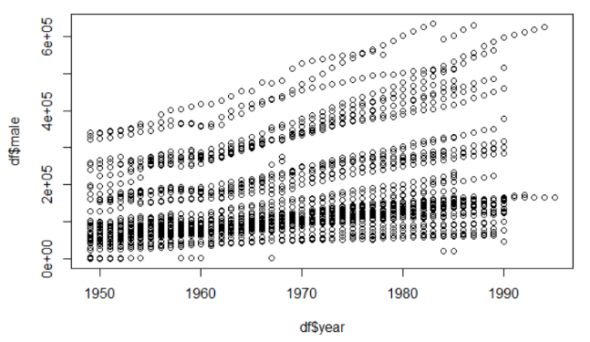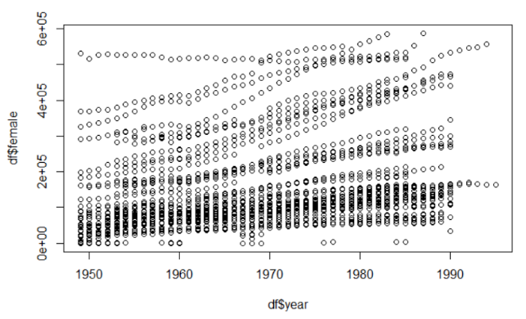Figure 3-1 Overall demographic trends

After the feature importance analysis, I selected the first fifteen most important control variables. Combined with other missing records, I selected six most relevant and important variables to analyze.

3.2 Desciptive statistics

Our main dependent variable is the sex ratio of the county-level birth population from 1949 to 1965, based on the data published by the China Gazetteer Project and the United Nations (The sex ratios greater than 5 and less than 0.1 are removed. Extreme values ​​may be due to manual input errors).

In the county-level data, the sex ratio at birth in China during the collectivization period is close to the normalization of biological significance. In 2005, the overall male-female ratio in China was 118.88:100. The sex ratio at birth in Jiangxi, Guangdong, Hainan, Anhui, and Henan provinces even exceeded 130:100. In most countries, the male-female ratio is between 97.0:100 and 100.3:100, while the world average is between 105-107:100. It’s not hard to see, the male-female ratio in China has been highly distorted since the 1980s. This situation has continued to today (Loh and Remick, 2015). From this, we can see that it was indeed before the 1980s, that is to say, the sex ratio in the collectivization period was close to the normal range in the biological sense.

Figure 3-1 shows the time at which each county was undergoing different stages of collectivization and table 3-2 gives us a statistial description. At the same time, we can also see that the average number of population in each county is 269,700, which is almost the same as 255,100 people per county calculated in Chen and Lan (2017). And our data calculated the per capita arable land area is 0.189 hectares, the per capita agricultural output value is 0.048 million yuan and the total output is 0.456 tons per capita grain crop and the numbers in the paper by Li and Yang (2015) are 0.159, 0.023 and 0.347.

Figure 3-1 The percentage change of the three main stages in agricultural collectivization

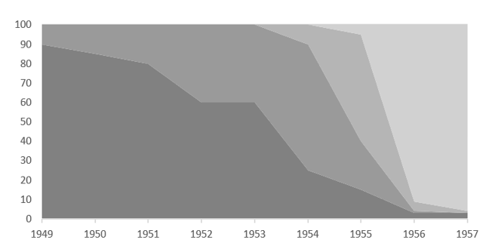

Note: From individual; mutual aid group of agricultural production; the primary agricultural production cooperative to the advanced agricultural production cooperative

But the numbers I got are slightly larger than theirs. This may be because I have collected more data until 1965, so the total agricultural output, food crop production and total population had increased. Therefore, it can also be explained that the data I selected is more representative.

Table 3‑2 Descriptive statistics of raw data

|  |  |  |  |  |  |
| --- | --- | --- | --- | --- | --- |
|  | Obersvations | Mean | S.d. | Min | Max |
| Mutal aid group | 540 | 0.85 | 0.36 | 0 | 1 |
| The primary cooperative | 540 | 0.73 | 0.44 | 0 | 1 |
| The advanced cooperative | 540 | 0.63 | 0.48 | 0 | 1 |
| Population  (Thousand people) | 878 | 269.7 | 204.7 | 7.75 | 998.6 |
| Total cultivated area  (Hectares) | 527 | 50.98 | 50.26 | 7.45 | 645.32 |
| Gross agricultural output value  (Ten thousand yuan) | 539 | 13000 | 4097.86 | 310 | 298,555 |
| Grain crop yield  (Ton) | 527 | 123.08 | 180.23 | 8.57 | 195.01 |
| Primary school students  (Thousand people) | 1006 | 36.86 | 39.14 | 0 | 400.83 |
| High school student  (Thousand people) | 1023 | 3.30 | 5.46 | 0 | 52.46 |
| Nuber of high schools（Number） | 1037 | 16.54 | 43.61 | 0 | 364 |

1. Results
   1. The influence of collectivation on gender ratio

Table 4-1 describes the statistical regression results. From columns (1) and (2), we can see that the presence of advanced agricultural production cooperative has a significant negative impact on gender ratio, regardless of whether or not the control variables are added. The primary agricultural production cooperative also has some influence, and the mutual aid group nearly has no impact. That is to say, at a significant level of 95%, the establishment of an advanced agricultural production cooperative can reduce the sex ratio at birth by about three percentage points. In column (3) of the table, I control the fixed effect at the county level. It can be clearly seen that the influence of advanced agricultural production cooperative on the sex ratio is still stable, and the influence of the primary agricultural production cooperative is also significant, but the significance level is lower. But it also shows that our results are not affected by a particular county. Similarly, I add the fixed effect of county level and year to the regression (i.e. column (5)). I found that the influence of the establishment of the advanced agricultural production cooperative on the sex ratio is still very significant, and there is almost no statistically significant difference between the previous results.

Table 4-1 Statistical results of the collectivation’s influence on gender ratio

|  |  |  |  |  |
| --- | --- | --- | --- | --- |
|  | （1） | （2） | （3） | （4） |
| Mutual aid group | 0.051 | 0.035 | -0.094 | -0.072 |
| Primary cooperative | -0.018 | -0.021* | -0.039 | -0.029 |
| Advanced cooperative | -0.033* | -0.026** | -0.034** | -0.033** |
| Cultivated area per capita |  | 0.001 | 0.062 | 0.052* |
| Agricultural output value per capita |  | 0.069* | 0.085 | 0.024* |
| Annual crop yield per capita |  | -0.001 | -0.002 | -0.001 |
| Number of primary schoold student per thousand people |  | 0.003* | 0.002* | 0.003* |
| Number of high school students per thousand people |  | 0.129 | 0.007 | 0.006 |
| Number of high school per thousand people |  | 0.018 | 0.033* | 0.036 |
| Constant | 9.923*** | 8.234 | 7.525 | 10.232 |
| County-level fix effects | N | N | Y | Y |
| Year fix effects | N | N | N | Y |
| Observations | 540 | 515 | 501 | 501 |

Note: * represents significant level at 10%; ** represents significant level at 5%; *** represents significant level at 1%.

* 1. Results from Shaanxi province

Table 4-2 describes the statistical regression results of Shaanxi Province. From the columns (1) and (2), we can see that whether or not the control variables like agriculture and education are added, the primary and the advanced agricultural production cooperatives both have significant negative impact on the sex ratio, which is consistent with the results of other provinces I have done. That is to say, the establishment of the advanced agricultural production cooperative in different counties will lower the male-female ratio at birth by about 2.8%, which is more normal in the biological way. In column (3) of the table, I still control the county-level fixed effect on the data of Shaanxi Province. It can be clearly seen that the influence of advanced agricultural production cooperative on the gender ratio is still stable, and the influence of the mutual aid group and the primary agricultural production cooperative are not. Obviously, that is to say, for Shaanxi Province, the time established by the advanced agricultural production cooperative also has a significant impact on the gender ratio, and at the same time it can also show that my results are not affected by a particular county. Similarly, I add the fixed effect of the year in the regression (i.e. column (4)) and the fixed effect of the county and the year at the same time (i.e. column (5)), I find that the establishment of the advanced agricultural production cooperative on gender ratio is still very significant, which is almost indistinguishable from the results of other provinces.

Table 4-2 Statistical results of the collectivation’s influence on gender ratio in Shaaxi

|  |  |  |  |  |  |
| --- | --- | --- | --- | --- | --- |
|  | （1） | （2） | （3） |  | （4） |
| Mutual aid group | 0.069 | 0.025 | 0.021 |  | 0.038 |
| Primary cooperative | -0.046 | -0.049* | -0.049 |  | -0.039 |
| Advanced cooperative | -0.038** | -0.037** | -0.039** |  | -0.038** |
| Cultivated area per capita |  | 0.024* | 0.028* |  | 0.018 |
| Agricultural output value per capita |  | 0.163 | 0.054 |  | 0.127 |
| Annual crop yield per capita |  | 0.003 | 0.004* |  | 0.002* |
| Number of primary schoold student per thousand people |  | 0.001* | 0.001 |  | 0.003 |
| Number of high school students per thousand people |  | -0.004 | -0.004 |  | -0.003 |
| Number of high school per thousand people |  | -0.092 | -0.081* |  | -0.064* |
| Constant | 5.812*** | 4.988 | 6.283 |  | 5.398 |
| County-level fix effects | N | N | Y |  | Y |
| Year fix effects | N | N | N |  | Y |
| Observations | 155 | 155 | 155 |  | 155 |

Note: * represents significant level at 10%; ** represents significant level at 5%; *** represents significant level at 1%.

In addition, we can visually see the effect of collectivization on gender ratio over time by the mean shift of β obtained by regression equation. If there is no influence of the collectivization, then the gender ratio at births in the 1950s should fall within a relatively stable range. That is to say, there is no major change before. Therefore, we now use the year in which the collectivization is carried out as a benchmark to observe whether the gender ratio at birth had changed.

I use $∆{SRB}_{it}$, which is to measure the change in male-female ratio at birth by using the difference between this year and the previous year. Because the establishment of high-level agricultural production cooperatives has a greater impact on the birth ratio in Shaanxi Province, I only measure the changes before and after the establishment of the advanced agricultural production cooperatives:

$$∆{SRB}_{it}=\sum_{k}{β_{k}}×I\left({CY}_{it}=k\right)+{year}_{t}+X_{it}+e_{it}$$

I use $∆{SRB}_{it}$ to filter out the county-level fixed effect $d_{i}$ in orginal regression equation. And I use a series of dummy variables $I({CY}_{it}=k)$ which can be used to indicate the kth year in the advanced agricultural production cooperatives; ${CY}_{it}=0$ means that the advanced agricultural production cooperatives was established; and ${CY}_{it}=1$ means the second year after the establishment of the senior society; ${CY}_{it}=-1$ means the year before the establishment of the advanced agricultural production cooperatives.

I now use the earliest year as the base year. If the male-female ratio at birth is not disturbed by any policy or social environment, then for $k<0$, $\hat{β_{k}}$ should be statistically no different from zero. However, due to the influence of the establishment of the advanced group on the sex ratio, $\hat{β_{0}}$ and $\hat{β_{1}}$ should be negative. $X_{it}$ contains the difference between other control variables as a function of year. Figure 4-3 shows the estimates of $\hat{β_{-1}}$, $\hat{β_{0}}$ and $\hat{β_{1}}$ in the regression and the 95% confidence level interval.

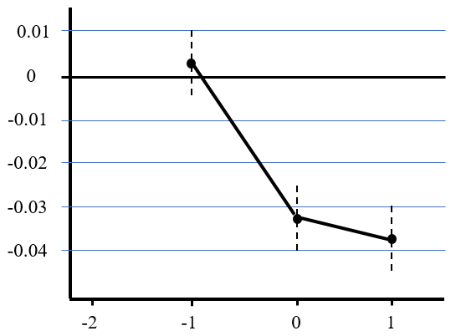

Figure 4-3 Dynamic change of the influence of collectivization on gender ratio

We can clearly see from the figure that the gender ratio at birth is maintained at an almost constant level without the influence of the establishment of the advanced group. In the years when the advanced agricultural production cooperatives was established and the years after it, there was a significant downward trend in the sex ratio. This downward trend is also consistent with the results in other provinces I have done before. In other words, without the influence of the establishement of advanced agricultural production cooperatives, the birth ratio will remain at this higher level.

1. Conclusions and Restrictions

When agricultural collectivization was launched throughout China, apart from collectivized labor and production form, there was an unprecedented change in women's social status. Women began to break the traditional mindset that they can only work at home. Under the encouragement of all the family to work, women began to enter the field to work with other women of the same age and even men, pursuing equal payment with men. This ideology influenced the strong male preferences that Chinese people have shown since ancient times. The entire Chinese society was no longer based on the economic structure of small-peasant families, and has begun to transform into socialist collectivized production based on agriculural cooperatives. Through my research on 46 counties in five provinces, I found that the establishment of a high-level agricultural production cooperative can reduce the sex ratio at birth by about three percentage points.

At the same time, because Shaanxi Province has a good revolutionary historical tradition and relatively complete data. The old revolutionary base areas in northern Shaanxi have a good foundation for mutual cooperation and cooperation, and it is much more easier to establish a cooperative agricultural cooperatives. Through statistical regression analysis of Shaanxi Province, I found that the establishment of a high-level agricultural production cooperative can reduce the male-female ratio of birth by about three percentage points even nearly four percentage points. In other words, when agricultural collectivization was developed to high-level agricultural production cooperative, it did normalize the sex ratio at birth to a certain extent.

The limitations of this paper mainly result from the lack of data and sample size. If I could include the implementation of the one-child policy in the regression results to divest the impact of this policy, I will get more convincing results. However, since the data of China’s last century is very scarce (a lot of them were destroyed in the Great Leap Forward period), our data is mainly from the records of the county records in Harvard Yenching Library. I strongly expect a more comprehensive integration of data covering more than 2,000 counties in China could be used in further research. This could lead us to a more convincing results.

References:

[1] Chen S, Lan X. There Will Be Killing: Collectivization and Death of Draft Animals[J]. American Economic Journal Applied Economics, 2017, 9(4):58-77.

[2] Almond D, Hongbin L, Zhang S. Land Reform and Sex Selection in China[J]. Nber Working Papers, 2013.

[3] Loh Charis, Remick Elizabeth J. China's Skewed Sex Ratio and the One-Child Policy[J]. The China Quarterly, 2015, 222:295-319.

[4] Zhu WX, Lu L, Hesketh T. China's excess males, sex selective abortion, and one child policy: analysis

of data from 2005 national intercensus survey[J]. BMJ: British Medical Journal, 2009, 338(7700):920-923.

[5] Winckler, Edwin A. Governing China's population :[M]. Stanford University Press, 2005.

[6] Zeng Y, Tu P, Gu B, et al. Causes and Implications of the Recent Increase in the Reported Sex Ratio at

Birth in China[J]. Population & Development Review, 1993, 19(2):283-302.

[7] Ebenstein A. The "Missing Girls" of China and the Unintended Consequences of the One Child

Policy[J]. Journal of Human Resources, 2010, 45(1):87-115.

[8] Edlund L. Son preference sex ratios and marriage patterns.[J]. Journal of Political Economy, 1999,

107(6):1275-1304.

[9] Zitzewitz E. Forensic Economics[J]. Journal of Economic Literature, 2012, 50(3):731-69.

[10] Chen Y, Li H, Meng L. Prenatal Sex Selection and Missing Girls in China[J]. Journal of Human Resources, 2013.

[11] Becker G S. An Economic Analysis of Fertility, Demographic and economic change in developed countries : a conference of the Universities -[J]. National Bureau Commitee for Economic Research, 1960, 209.

[12] Li L, Yang X J. Tubulin acetylation: responsible enzymes, biological functions and human diseases[J]. Cellular & Molecular Life Sciences, 2015, 72(22):4237-55.

[13] Chan C L W, Yip P S F, Ng E H Y, et al. Gender Selection in China: Its Meanings and Implications[J]. Journal of Assisted Reproduction & Genetics, 2002, 19(9):426-430.

[14] Prenatal sex determination and sex-selective abortion[J]. Nursing Standard, 2005.

[15] Ding Q J, Hesketh T. Family size, fertility preferences, and sex ratio in China in the era of the one child family policy: results from national family planning and reproductive health survey.[J]. Bmj, 2006, 333(7564):371-373.

[16] Xiaoyi Jin, Lige Liu, Yan Li, et al. "Bare Branches" and the Marriage Market in Rural China[J]. Chinese Sociological Review, 2013, 46(1):83-104.

[17] 谷加恩. 人民公社时期农村合作医疗事业成功的原因探析[J]. 武汉职业技术学院学报, 2006, 5(1):28-31.

[18] 曹普. 人民公社时期的农村合作医疗制度[J]. 中共中央党校学报, 2009, 13(6):80-85.

[19] 严运楼. 毛泽东对人民公社时期农村合作医疗的探索[J]. 毛泽东思想研究, 2007, 24(6):36-38.

[20] 王翠云. 人民公社化时期农村敬老院研究综述[J]. 党史文苑, 2016(12):74-76.

[21] 王翠云. 人民公社化运动时期上海市郊区敬老院研究[D]. 华东师范大学, 2017.

[22] 张寿春. 人民公社化运动及人民公社问题研究综述[J]. 当代中国史研究, 1996(3):82-88.

[23] 汪前珍. 人民公社化运动时期的妇女解放[D]. 湖南科技大学, 2010.

[24] 邱国盛. 20世纪50年代上海的妇女解放与参加集体生产[J]. 当代中国史研究, 2009(1):70-77.

[25] 高凌. 我国人口出生性别比的特征及其影响因素[J]. 中国社会科学, 1995(1):99-115.

[26] 解振明. 引起中国出生性别比偏高的三要素[J]. 人口研究, 2002, 26(5):14-18.

[27] 曾毅, 顾宝昌, 涂平,等. 我国近年来出生性别比升高原因及其后果分析[J]. 人口与经济, 1993(1):3-15.

[28] 乔晓春. 性别偏好、性别选择与出生性别比[J]. 中国人口科学, 2004(1):14-22.

[29] 穆光宗. 近年来中国出生性别比升高偏高现象的理论解释[J]. 人口与经济, 1995(1):48-51.

[30] 顾宝昌, 罗伊. 中国大陆、中国台湾省和韩国出生婴儿性别比失调的比较分析[J]. 人口研究, 1996(5):1-16.

[31] 于弘文, 邓国胜, 王宗萍,等. 透视出生性别比偏高现象[J]. 人口研究, 2003, 27(5):38-52.

[32] 高凌. 中国人口出生性别比的分析[J]. 人口研究, 1993, 17(1):1-6.

[33] 李树茁, 朱楚珠. 中国出生性别比和女婴生存状况分析[J]. 人口与经济, 1996(1):13-18.